The Great Climb
No one remembers seeing the summit. Everyone remembers someone who went looking for it.
You are climbers on the face of Mount Aster, where the road upward takes weeks and the summit is said to grant eternal life. Camps become villages. Ropes outlast their makers. Your hands harden to stone, ice, and the weight of the people tied to you.
The Great Climb is a cooperative tabletop roleplaying game about longing, endurance, and shared risk. You may disagree about the summit, but you ascend on one rope: a slip strains everyone, and a true fall takes the whole team.
Physical components. This game uses one STEPS playing platform and its wooden pieces. It adapts those components into a new cooperative check system; it does not use STEPS' competitive scoring or penalty rules. See About the Components for credit and an accessibility option.

The Mountain
Mount Aster rises beyond every known map. From its foot, the upper face looks close enough to reach in a few days. From the first high camp, climbers learn that distances on Aster are measured in weeks.
The old promise is simple: reach the summit and live forever. No witness agrees about the source. Some speak of a spring beneath the final snow; others of a door that opens only when a rope team arrives together. Guides, pilgrims, physicians, and rulers have spent generations testing the claim. Nobody has brought down proof. Nobody has brought down a convincing denial.
The mountain is not empty. Camps change hands; families are born without seeing the lowlands. Trade runs vertically: lamp oil upward, messages downward. Shrines of bent tools, dead weather stations, and ancient ropes mark the way.
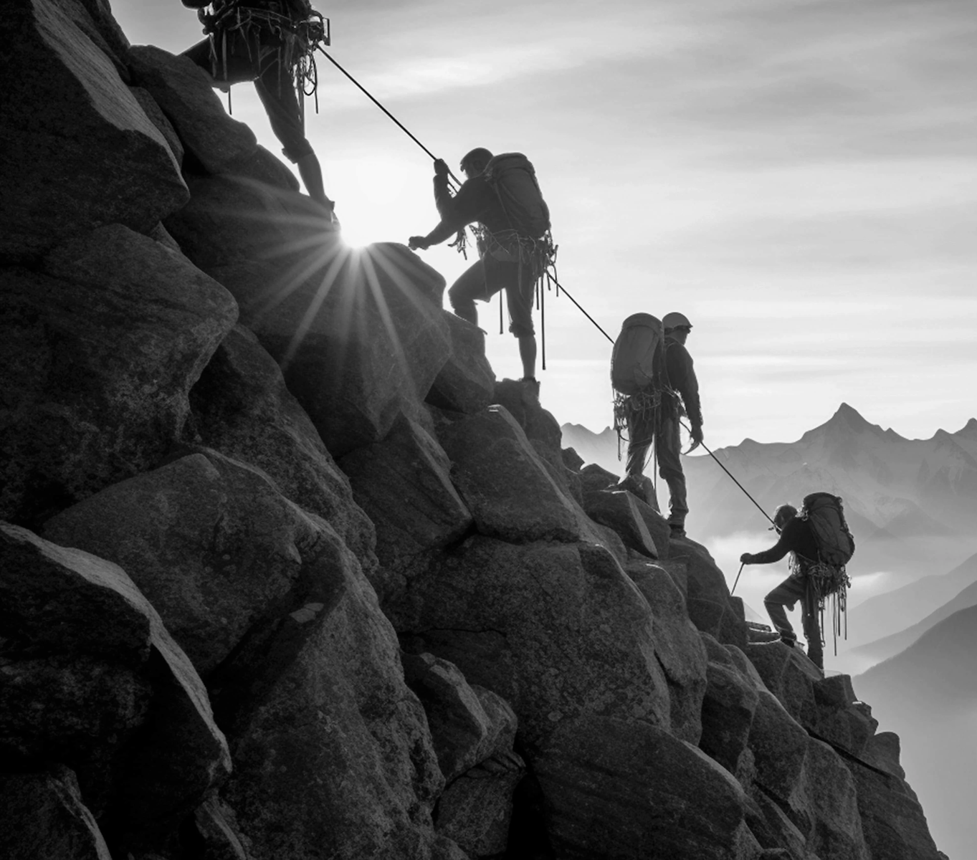
Climbers on the ascent

Five faces of the ascent
- The Green Foot: rain, loose soil, rooted stone, and the last reliable roads. Here people still speak of returning.
- The Broken Stair: sheer bands, hanging bridges, and camps stacked in old quarry cuts. The first hard week separates visitors from residents.
- The White Reach: snowfields over crevasses, blank horizons, and wind that moves a camp while its occupants sleep.
- The Breathless Wall: bare rock above most shelter. Voices carry badly; gestures become a language of their own.
- The Crown: a dark shape glimpsed only between storms. Its form should remain uncertain until the team earns the sight of it.
These faces are a reading path, not five required levels. A route can cross back through lower terrain; a fall can make yesterday's hard-won altitude unreachable. Let the team draw and annotate its own mountain map.

What weeks do
Long exposure is ordinary here. Hands harden around rope fibers. Skin cracks, heals, and cracks in the same places. Climbers learn the smell of incoming snow and the exact weight of another person falling. Aster's eeriness should rise from that ordinary adaptation: a veteran may forget the feel of warm rain while remembering every hold on a wall crossed three weeks ago.
Keep the summit's truth open for now. What matters at the start is why these climbers believe it, and what they are willing to keep carrying upward.

The Climbers
Make one climber each on a 3 × 5-inch flash card. Write a name, weeks on Aster (start at 0), and a place below you still call home. Then answer in a few words:
- What does eternal life let you keep, or finally let you do?
- Who on this rope would you catch without thinking? Why?
- What did you bring that cannot be replaced?
Circle one trained skill. Every climber can attempt all three; the chosen skill gives one tile reduction per leg when it fits the check. Mark it used, then refresh it at the next camp.
- Strength: Grip, haul, carry, brace, or set an anchor. Use it when force and control hold the mountain in place.
- Courage: Step onto an exposed crossing, enter an unknown gap, or act while afraid. Use it when committing is the obstacle.
- Willpower: Endure cold, hunger, sleeplessness, or a long hold. Use it when the challenge is continuing rather than beginning.
Before pieces are flipped, say how the trained skill helps. If it addresses the declared danger, reduce the check by one tile, minimum one. Only the leader's trained skill applies, even when another player makes the throw. A skill does not replace a route, a tool, or an explanation.
Each climber begins with 0 Exposure and one personal object. Exposure measures injury, cold, and exhaustion. Describe wounds freely; the number is what matters in the rules.
On the back of a card, draw the team as names connected by a single line. Write one promise between each pair of neighbors. The rope is physical gear, but the drawing records who is responsible for whom. The team cannot cut a climber free to cancel a failed check.

The body learns
Whenever a week passes, increase WEEKS by 1 and add one permanent visible change: callused palms, a wind-bent stance, frost-pale eyelashes, a voice made thin by altitude, or something stranger. It is a record, not a bonus. Add one sentence about what the climber now finds ordinary that would once have frightened them.
You may change your reason for climbing. Do not erase the original answer; cross it out so the team can see what the mountain took.

The Ascent
The Guide describes the terrain and its visible danger. The team chooses a route and names one climber to lead. If an outcome is safe and certain, it happens without a check. Ask for a check only when failure would change the climb.

Tile checks
Use one STEPS platform and shared pieces. Before a check, the Guide states the reward, the fall risk, and the tile count:
Tiles | Crossing
1 | Precarious but prepared
2 | Dangerous; the ordinary climb
3 | Severe weather or exposed terrain
4 | Desperate; several dangers at once

The leader flips or tosses the required pieces onto the platform, one at a time, with a visible turn in the air. The team chooses each available piece. A teammate may throw for the leader; everyone may advise. Do not touch the platform or placed pieces during a check. If any piece falls off, including an earlier one, or a throw misses, the check fails. If all pieces remain, it succeeds. Leave them in place.
The leader's unused trained skill reduces the check by one tile if it addresses the danger; mark it used until camp. Another climber may first make a supporting check, such as placing a piton. Success reduces the main check by one if it removes a danger; failure has the usual consequences. The Guide decides what fits. A sound route or equipment may remove a danger without a check. Allow only one reduction from support or preparation, plus one from skill, never below one tile. Storm, failing light, a leader at 2 Exposure, each climber at 3 Exposure, and Rope Strain at 2 or 3 may each add one. A result over four needs changed circumstances.
The structure persists between checks and scenes. Clear it only after securing a new camp or a true fall.
If no pieces remain to throw, the overloaded structure sheds a piece. Resolve a failed check normally.

Slips, Strain, and falls
Track Rope Strain for the whole team from 0 to 3. If Strain is below 3, a fallen tile means a slip: the check fails, the leader gains 1 Exposure, and Rope Strain rises by 1. The rope catches them; the team does not fall.
The attempted action does not succeed. The Guide shows one concrete setback already implied by the danger, such as lost time, damaged equipment, worse footing, or a blocked route. Leave any discoveries intact. Return fallen tiles to the supply after resolving the check; pieces still on the platform stay in place.
At 2 or 3 Strain, add one tile to subsequent checks. If a check fails while the rope is already at 3 Strain, the catch finally fails instead of an ordinary slip: the entire tethered team falls to its last secured camp or anchor. Each climber gains 1 Exposure, the attempted route is lost, Rope Strain returns to 0, and the platform is cleared. The leader does not take an extra point for slipping. Describe the cascade: one foot slips, the line snaps taut, and every climber is dragged after the first. The Guide may add a specific cost already signaled by the danger, but not a surprise death.
Strain does not disappear after an ordinary success. The Guide may offer a secure anchor as a route objective; reaching it reduces Strain by 1 and gives the team a nearer place to land after a true fall. An anchor does not clear the platform. A new camp clears all Strain. The team cannot declare an anchor in empty air or repeat a safe action to erase Strain.
At 2 Exposure, a climber adds one tile to checks they lead. At 3 Exposure, they add one tile to every team check, including checks led by others. They can still lead or throw. Exposure stays at 3 if they would gain more. Share the lead before anyone reaches this point. Death requires an established danger that makes rescue impossible, never a bare tile result.

Making camp
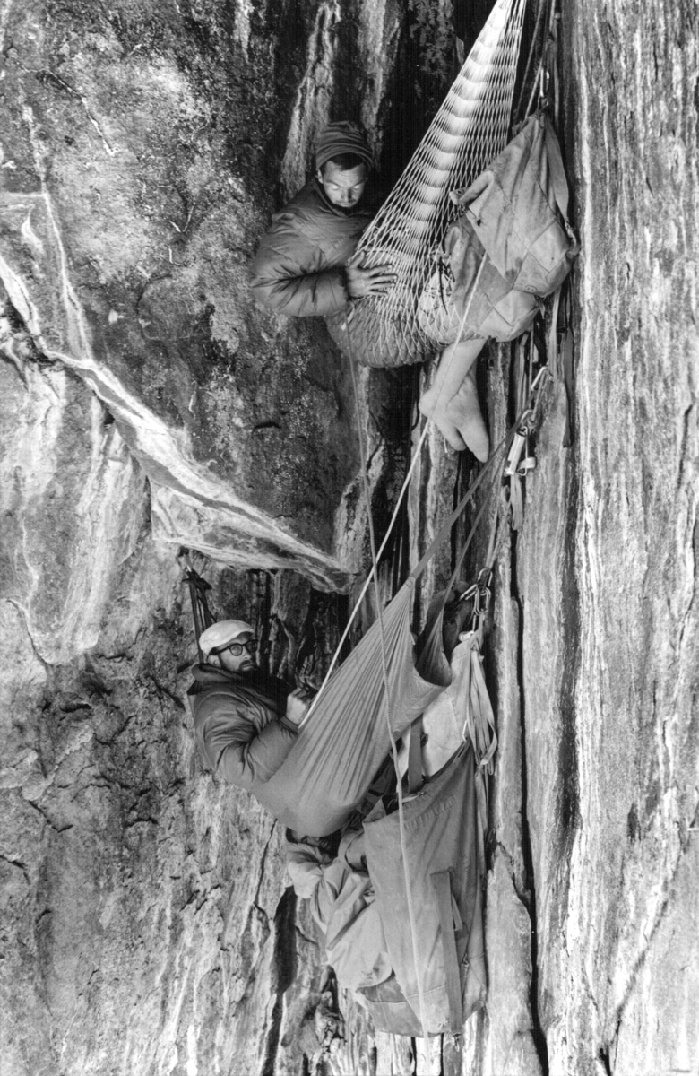
A bivouac on the wall
To secure a new camp, make one final check against its exposed ground, weather, or shelter work. Name the danger and tile count as usual. On failure, resolve the slip or fall; the camp is not yet secure and no Exposure clears. The team must change its approach before trying again.
On success, clear the platform and Rope Strain. Every climber clears 1 Exposure and refreshes their trained skill. A full week of rest clears all Exposure, but the Guide changes the mountain. The team decides whether the time is worth it.

The climb's rhythm
Each leg has a destination camp and two or three meaningful obstacles. The team scouts, chooses a route, lives with falls, and secures or abandons the camp. Each secured new camp counts as one ascent and roughly one week. A full week spent resting at camp also passes. In either case, record the changes from The Climbers. The Guide does not advance weeks just to punish caution.
When completed ascents equal twice the number of climbers currently on the rope, end the game. The summit remains out of reach, but the team gains a view none imagined. Ask each climber what they now know about the others and whether they would keep climbing together.

Running the Mountain
The Guide is the mountain's voice, not an opponent at the platform. Give the team enough information to make a real choice: visible hazards, a plausible safe route, and the cost of delay. Ask what they do before naming a tile count. Do not demand a check for ordinary travel, competent preparation, or repeating ground whose danger has been solved.
Before a check, say: “This gains you ____. A slip costs ____. A true fall returns you to ____.” Name the last secured anchor. If failure would only make the team try the same throw again, change the scene or skip the check.
Use one or two tiles for most actions. Three tiles means a hard choice; four should be rare and telegraphed. Weather is not simply a difficulty tax. Show what it does to the route: ice seals a crack, rain loosens a traverse, or wind exposes a safer line behind a dangerous one. Let preparation remove a named danger and reduce the count.
On an ordinary failed check, the rope catches a slip. Mark the leader's Exposure and the team's Rope Strain, then show the setback without moving everyone to camp. A revealed handhold, a torn map, or a shelter seen from below can all survive failure. If the rope was already at 3 Strain when the check failed, the whole team truly falls. Ask each player for one instant of the cascade, move them to the last anchor, and show what changed. Even that loss should create a new decision rather than erase every discovery.

First leg: The Bell Traverse
The team leaves the Green Foot for a camp under a ruined weather bell. On one side of the traverse is wet stone above a long drop; on the other, an older stair disappears under a fresh slide. Both reach the bell, but neither is wholly safe.
- Wet traverse: two tiles. Strength to brace an anchor or waiting for the rain to pass could reduce it to one. A slip tears loose a handhold and raises Rope Strain; a true fall returns the team to the last pinned rope.
- Buried stair: one tile to uncover and test. Success reveals a slower route to the bell; failure exposes a hollow under the slide and blocks the stair until the team braces it.
- At the bell: a dry niche can become the next camp. Inside is a slate bearing the names of three climbers who have not yet arrived. Decide whether it is a warning, an error, or evidence of something above.
The team should be able to reach the bell by planning, changing routes, or accepting a fall. Do not make a particular check the only door forward.

Boundaries and access
Ask the table about injury, exposure, abandonment, and death; anyone can pause a scene. Throwing skill is not character competence. A player may direct someone else's throw while choosing the pieces and approach. The same tile count and consequences apply.

Play aids

Climber Card
Copy onto a 3 × 5-inch card.
NAME __________________ WEEKS ON ASTER ____
HOME ______________________________________
WHY THE SUMMIT? ___________________________
IRREPLACEABLE OBJECT ______________________

TRAINED (circle one; use once per leg)
STRENGTH: grip, haul, brace, carry
COURAGE: exposed or frightening action
WILLPOWER: cold, fatigue, long effort
USED THIS LEG [ ] EXPOSURE [ ] [ ] [ ]

BODY CHANGE / WHAT NOW FEELS ORDINARY:
__________________________________________

BACK: Draw the rope team. Write a promise
between each pair of neighboring climbers.
On a check, the leader names the danger and how their trained skill meets it. If it fits, flip one fewer tile (minimum one) and mark USED. The team shares a separate Rope Strain track. See The Ascent.

Quick Reference

Before a check
- Describe the danger and ask for the team's route.
- Name the leader, the reward, the slip setback, and the last secured anchor.
- Set 1 to 4 tiles. The leader's unused trained skill may reduce the count by one. Successful support or specific preparation may reduce it by one more, never below one. Storm, failing light, a leader at 2 Exposure, each climber at 3 Exposure, or Rope Strain at 2 or 3 may each add one. A result over four needs changed circumstances.

At the platform
- Use the same shared structure until a new camp is secured.
- Flip or toss one chosen piece at a time with a visible turn in the air.
- Teammates may take throws or advise.
- If any piece falls off, stop: the check fails and the rope catches a slip, unless Strain was already 3.
- If all required pieces remain, the action succeeds. Leave them in place.

After a failed check
- On an ordinary slip, the leader gains 1 Exposure; Rope Strain rises by 1 (maximum 3).
- The action fails. Show a concrete setback and what the slip taught.
- At Strain 2 or 3, add one tile to future checks.
- If Strain was already 3 before failure, the entire team falls to its last anchor instead. Each gains 1 Exposure (no extra point for the leader); clear Strain and the platform.
- At 2 Exposure, add one tile to checks that climber leads.
- At 3 Exposure, that climber adds one tile to every team check, but can still lead or throw. Exposure cannot exceed 3.

Securing camp
- Make one final check for the camp. On failure, resolve the slip or fall; no Exposure clears. Change the approach before another attempt.
- On success, clear the platform and recover all pieces.
- Clear Rope Strain.
- Each climber clears 1 Exposure. A full week of rest clears all, but the mountain changes.
- Refresh each trained skill's once-per-leg use.
- After each new camp or full week of rest, increase WEEKS by 1 and record one permanent bodily change.
- Count one ascent for each secured new camp. End after twice as many ascents as climbers currently on the rope.

Notes and credits

About the Components
The Great Climb uses a STEPS Starter Pack as its physical resolution tool. Its shared structure, checks, rope, Exposure, and setting are original adaptations, not STEPS rules. This independent game is not affiliated with or endorsed by STEPS Games.
The official STEPS rules explain the original game. For this game, follow The Ascent where procedures differ. Pieces are shared; each check specifies a number of throws; a fallen piece fails the check.
Bring one STEPS platform and its pieces, paper for the rope team and map, and a way to mark Exposure. A player may direct another person's throw.

Photo credits and licenses
These terms apply to the photographs in this folder, not to the text or rules of The Great Climb. Keep this note with the images when sharing the vault. Check the linked source pages again before a public or commercial release.

Tom Frost, Tenement Flat (1964)
- Local file: Portaledge.webp
- Photographer and required credit: Tom Frost.
- Source: Wikimedia Commons file page.
- License: Creative Commons Attribution 3.0 Unported (CC BY 3.0).
- Use: Sharing and adaptation are allowed, including commercial use. Credit Tom Frost, link to the source and license, and say whether you changed the image. Do not suggest he endorses this game.
Suggested credit for the local copy: “Tenement Flat (1964), photograph by Tom Frost, CC BY 3.0, via Wikimedia Commons. Converted to WebP.” If you crop, recolor, or otherwise edit it, describe those changes too.

Extreme mountain climbers at exploration of mountain peak
- Local file: Climb.webp
- Photographer: djovan.
- Source: Pixnio image page.
- License: Pixnio License, not CC0. The image page identifies this photo as licensed for free use under Pixnio's terms.
- Use: Personal and commercial use and modifications are permitted. Attribution is not required, but is appreciated. Do not resell unmodified copies, redistribute it on a competing stock-photo or wallpaper site, or imply endorsement. Pixnio also warns that separate rights, such as a recognizable person's privacy or publicity rights, may still matter.
Optional credit: “Photograph by djovan, via Pixnio, used under the Pixnio License.”

The Great Climb License
Except where otherwise noted, the original game text and artwork in The Great Climb, including its mountain icon, are © 2026 TechInTheKitchen and are licensed under the Creative Commons Attribution-NonCommercial 4.0 International License (CC BY-NC 4.0).
You may share and adapt this original material for noncommercial purposes, provided that you give appropriate credit, link to the license, and indicate whether changes were made.
License summary: https://creativecommons.org/licenses/by-nc/4.0/
Full legal code: https://creativecommons.org/licenses/by-nc/4.0/legalcode
The Great Climb name and associated logos are not licensed for use as trademarks or to imply endorsement.
Third-party software and material retain their respective licenses. In particular:
- The web reader code and copied template components retain their MIT notice in assets/reader-license.txt.
- The photographs in Art are not covered by this CC BY-NC license. Their credits and separate terms are in Art/Photo Credits and Licenses.md.
- STEPS and its physical components are not part of this license. See About the Components.md.

